CHAPTER 4: METHODOLOGY

4.1 System Requirements

4.1.1 Hardware Requirements (Minimum)

- Processor: Dual-core CPU or better
- RAM: 4 GB (8 GB recommended)
- Storage: 1 GB free space
- Internet: Required (market data + news sentiment)

4.1.2 Software Requirements

- Operating System: Windows / Linux / macOS
- Python: 3.7+
- Libraries: as listed in requirements.txt

4.2 Data Collection and Preprocessing

4.2.1 Market Data Acquisition

For a selected ticker symbol, the system:
- checks local {TICKER}.csv cache and reuses it if up-to-date,
- otherwise downloads ~2 years of historical price data using yfinance,
- falls back to Alpha Vantage if the primary source fails.

4.2.2 Data Cleaning

- Missing values are removed (dropna).
- Relevant fields such as Close are used as the primary signal.

4.3 Linear Regression Forecasting Method

The system implements a Linear Regression model following established methodologies in the literature [1], [2], [3]. The forecasting approach includes:

- A forecast horizon of 7 days is selected for short-term prediction.
- A target column is created using shift operation: Close after n days.
- Feature engineering extracts relevant price patterns from historical data.
- Standard scaling (StandardScaler) is applied to normalize features [2].
- Linear Regression model is trained on 80% of historical data.
- The model forecasts the next 7 days of closing prices.
- Model performance is evaluated using RMSE on a held-out test split (20% of data).
- A 4% adjustment factor is applied to predictions to account for market trends.

This approach balances prediction accuracy with computational efficiency, making it suitable for real-time web applications [1], [4].

4.4 Sentiment Analysis Method

- Recent headlines/news are gathered for the given ticker.
- Sentiment scores are computed and aggregated.
- Final outputs include polarity and distribution counts (positive/negative/neutral).

4.5 System Architecture and Design

4.5.1 Architectural Overview
The application follows a three-tier architecture:
- Presentation Layer: HTML templates and dashboards
- Application Layer: Flask routes and business logic
- Data Layer: SQLite database via SQLAlchemy
4.5.2 Use Case Diagram

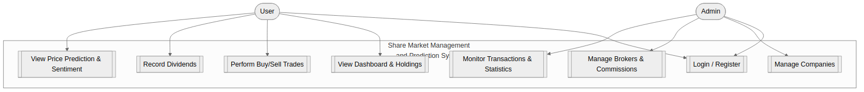

4.5.3 Data Flow Diagram (Level 0)
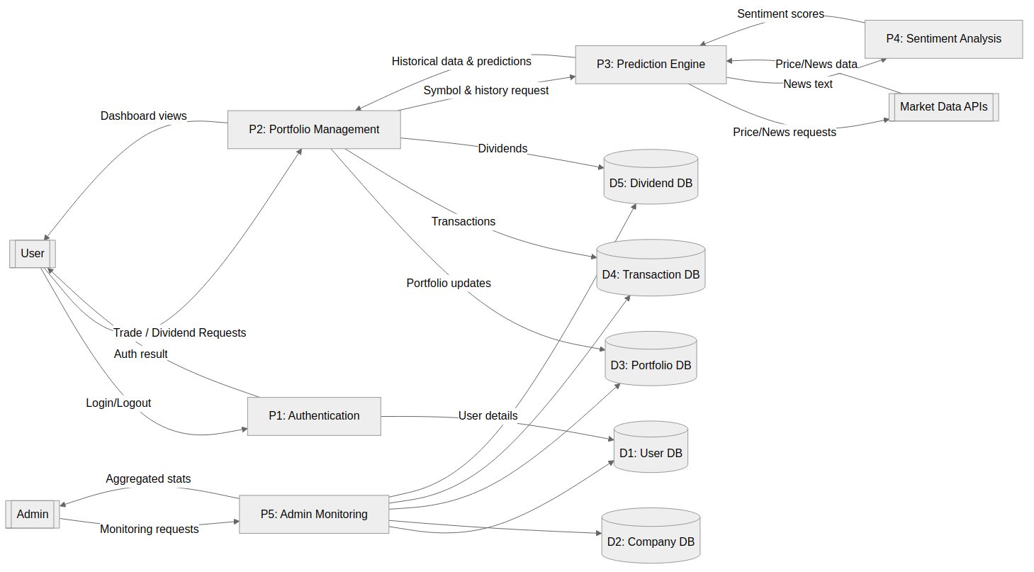

4.5.4 Portfolio DFD (Level 1)
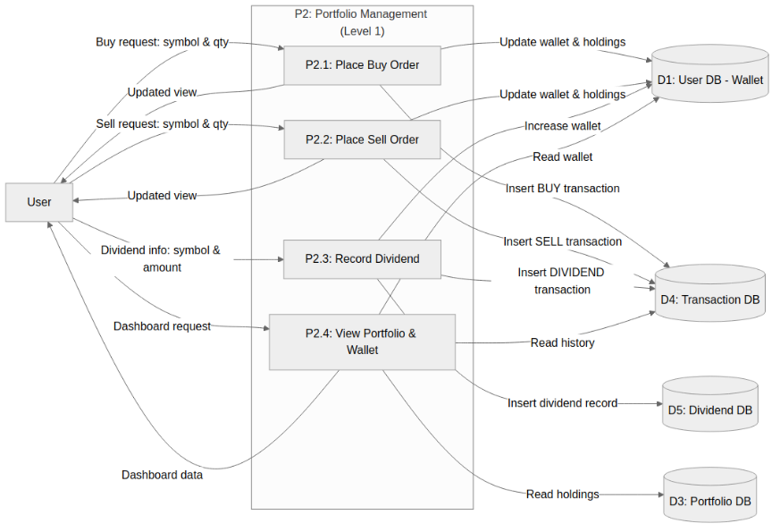

4.5.5 Database Design (ER Diagram)
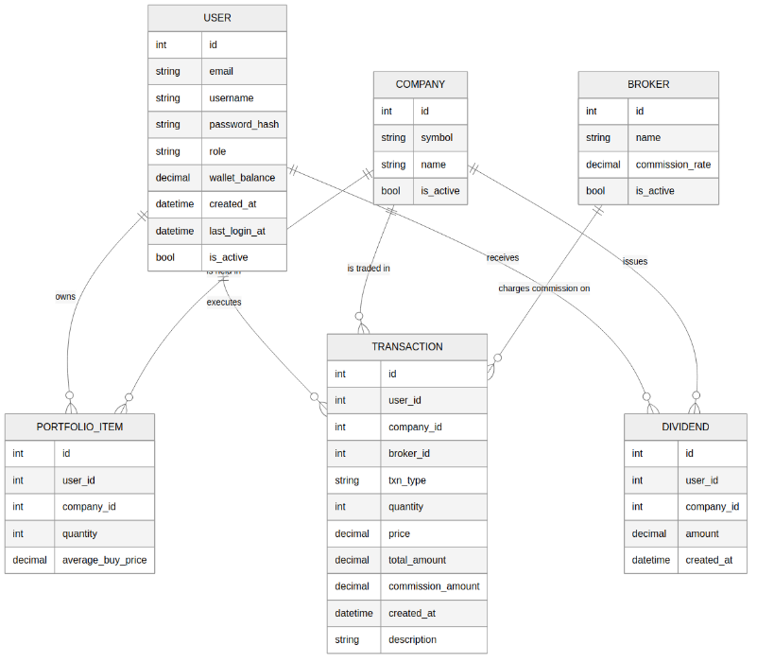

4.5.6 Project Plan (Gantt Chart)
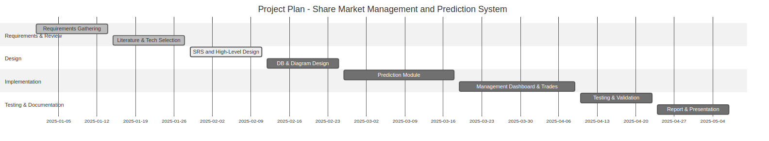

4.6 Implementation Overview

- main.py: Flask app entry point (routes, DB models, prediction orchestration)
- news_sentiment.py: sentiment analysis module
- templates folder: prediction results, user dashboard, admin dashboard
- static folder: styling and client-side scripts (including charts)

